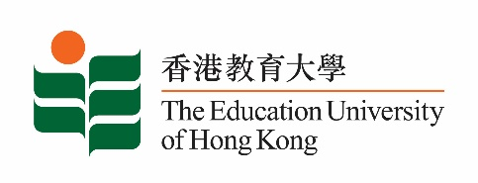
致： 傳媒機構採訪主任 5 April 2024
To : News Editors

香港教育大學2024年 4月8至 4月21日可供採訪之活動一覽
The Education University of Hong Kong (EdUHK) Events Calendar for 8-21 April 2024
本校誠邀 貴機構派員採訪下列活動。傳媒查詢，請聯絡教大傳訊處（電話：2948 6050）。
You are cordially invited to cover the events below. For media enquiries, please contact the Communications Office at 2948 6050.

以下活動或有人數限制，傳媒請預先向主辦部門登記。
There may be restrictions on the number of participants for the following event(s). Please contact the respective organiser(s) / department(s) for prior registration.

- 教大大埔校園 （新界大埔露屏路十號） / EdUHK Tai Po Campus (10 Lo Ping Road, Tai Po, New Territories)

日期  Date | 時間  Time | 活動  Event | 地點  Venue | 主辦部門及公眾查詢  Organiser &  Public Enquiry | 備註  Remarks
8-13 April 2024 | 9:00-5:30pm | 2023-24 Master of Arts in Visual Arts Education and Creative Practice Capstone Project Exhibition  2023-24 視覺藝術教育與創意實踐文學碩士畢業作品展 | 教大大埔校園, B2-P-01 CCA Gallery  B2-P-01 CCA Gallery, EdUHK Tai Po Campus | 主辦部門 / Organiser:  Department of Cultural and Creative Art  文化與創意藝術學系  查詢 / Enquiries:  蔡小姐Ms. Cherry Choi;  電話/ Tel: 2948 7225;  Email: mavaecp@eduhk.hk | 免費入場，  歡迎各界人士參加。Free admission.  All are welcome.  歡迎預約免費導賞團  Free guided tours can be arranged by appointment

